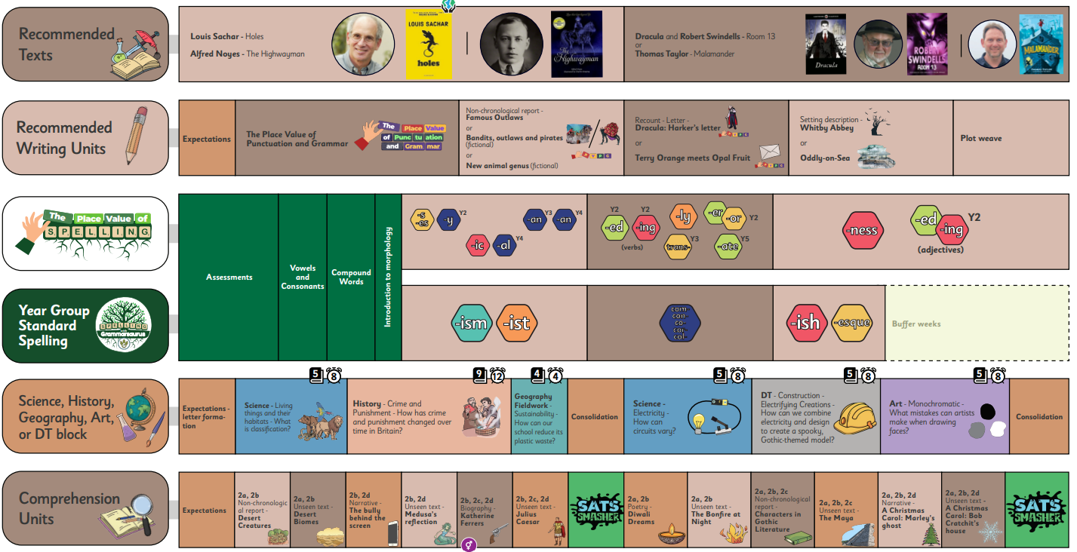
In addition to this, we are also going to be learning about:
- Maths: place value, addition, subtraction, the order of operations (B.I.D.M.A.S), perimeter and area
- PE: Gymnastics
- PSHE: keeping healthy, feelings and emotions
- Music: dynamics, pitch and texture
- RE: Islam and the concept of peace
- My Happy Mind: meet the brain unit
Homework:
Homework will be handed out on Fridays and due on the following Thursday.
Please encourage your child to be reading regularly at home (ideally for at least 20 minutes a day).
TTRS: your child should also be logging into TTRS to practice their times tables and improve their fluency. If you are unsure of your child’s login, contact their class teacher.

