Pupil premium strategy statement
Haylands Primary School
This statement details our school’s use of pupil premium (and recovery premium) funding to help improve the attainment of our disadvantaged pupils.
It outlines our pupil premium strategy, how we intend to spend the funding in this academic year and the outcomes for disadvantaged pupils last academic year.

School overview 2023 / 24
Detail | Data
Number of pupils in school | 361
Proportion (%) of pupil premium eligible pupils | 31%
Academic year/years that our current pupil premium strategy plan covers (3 year plans are recommended) | 23 - 25
Date this statement was published | July 2023
Date on which it will be reviewed | July 2024
Statement authorised by | Katrina Shaer
Pupil premium lead | Katrina Shaer
Governor / Trustee lead | Simon Richards

Funding overview
Detail | Amount
Pupil premium funding allocation this academic year | £159,890
Recovery premium funding allocation this academic year | £15,479
Pupil premium (and recovery premium*) funding carried forward from previous years (enter £0 if not applicable)  *Recovery premium received in academic year 2021 to 2022 can be carried forward to academic year 2022 to 2023. Recovery premium received in academic year 2022 to 2023 cannot be carried forward to 2023 to 2024. | £0
Total budget for this academic year  If your school is an academy in a trust that pools this funding, state the amount available to your school this academic year | £175,369

Part A: Pupil premium strategy plan

Statement of intent
When making decisions about using Pupil Premium funding it is important to consider the context of the school and the subsequent challenges faced. This alongside research conducted by the EEF. Common barriers to learning for disadvantaged children can be: less support at home, weak language and communication skills, lack of confidence, more frequent behaviour difficulties and attendance and punctuality issues. There may also be complex family situations that prevent children from flourishing. The challenges are varied and there is no “one size fits all”.
High-quality inclusive teaching is at the heart of our approach, with a focus on areas in which disadvantaged pupils require the most support. This is proven to have the greatest impact on closing the disadvantage attainment gap and at the same time will benefit the non-disadvantaged pupils in our school. Implicit in the intended outcomes detailed below, is the intention that non-disadvantaged pupils’ attainment will be sustained and improved alongside progress for their disadvantaged peers.
Our approach will be responsive to common challenges and individual needs, rooted in robust diagnostic assessment, not assumptions about the impact of disadvantage. The approaches we have adopted complement each other to help pupils excel. To ensure they are effective we will:
- ensure disadvantaged pupils, along with all pupils, are challenged in the work that they’re set
- act early to intervene at the point need is identified
- adopt a whole school approach in which all staff take responsibility for disadvantaged pupils’ outcomes and raise expectations of what they can achieve.

Principles
• We ensure that teaching and learning opportunities meet the needs of all the pupils
• We ensure that appropriate provision is made for pupils who belong to vulnerable groups, this includes ensuring that the needs of socially disadvantaged pupils are adequately assessed and addressed
• In making provision for socially disadvantaged pupils, we recognise that not all pupils who receive free school meals will be socially disadvantaged
• We also recognise that not all pupils who are socially disadvantaged are registered or qualify for free school meals. We reserve the right to allocate the Pupil Premium funding to support any pupil or groups of pupils the school has legitimately identified as being socially disadvantaged
• Pupil premium funding will be allocated following a needs analysis which will identify priority classes, groups or individuals. Limited funding and resources means that not all children receiving free school meals will be in receipt of pupil premium interventions at one time
Demography and School Context
Haylands Primary is a two-form entry school located in Ryde, on the Isle of Wight The map below displays the “Index of multiple deprivation 2019” and shows the areas that surround the school and they are colour coded according to which national decile they belong to: decile 1 being the most deprived and decile 10 being the least deprived (IMD rankings). As you can see our school and the surrounding areas relatively near to the school have higher than average levels of deprivation, in which most of the pupils live, and are amongst the most deprived in the country.
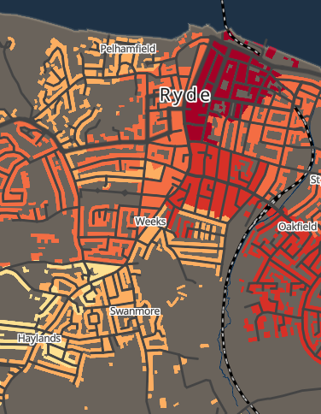
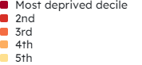

(screenshot of map taken from: https://mapmaker.cdrc.ac.uk/#/index-of-multiple-deprivation?m=imde19_rk&lon=-1.1677&lat=50.7255&zoom=13.33 )
Ultimate Objectives
• To narrow the attainment gap between disadvantaged and non-disadvantaged pupils nationally and also within internal school data
• For all disadvantaged pupils in school to exceed nationally expected progress rates in order to reach Age Related Expectation at the end of Year 6 and thus achieve GCSE’s in English and Maths.
Achieving These Objectives
The range of provision the Governors consider making for this group include and would not be limited to:
• To allocate a ‘Catch Up’ Teacher to Key Year Groups - providing small group work with an experienced teacher/HLTA focussed on overcoming gaps in learning
• 1-1 support
• Additional teaching and learning opportunities provided through trained LSAs or external agencies
• All our work through the pupil premium will be aimed at accelerating progress, moving children to at least age-related expectations
• Pupil premium resources are to be used to target able children on Free School Meals to achieve Age Related Expectations
• Transition from primary to secondary and transition internally and into EYFS
• Additional learning support
• Subsidise and in some cases pay for all activities, educational visits and residentials. Ensuring children have first-hand experiences to use in their learning in the classroom
• Support the funding of specialist learning software
• To allow the children to learn a musical instrument
• Behaviour and nurture support by providing activities to engage and promote Haylands values and thus enhance learning supported by employing a full time CFLO and part time ELSA
This list is not exhaustive and will change according to the needs and support our socially disadvantaged pupils require.

Challenges
This details the key challenges to achievement that we have identified among our disadvantaged pupils.
Challenge number | Detail of challenge
1 | Weak language and communication skills effecting writing and reading
2 | Low attainment on entry to the EYFS in all areas
3 | More frequent SEMH difficulties
4 | Attendance and punctuality issues
5 | Chaotic family lives and social service involvement

Intended outcomes
This explains the outcomes we are aiming for by the end of our current strategy plan, and how we will measure whether they have been achieved.
Note: there has been a change of headteacher, deputy headteacher and SENCo since the 3 year plan was formulated. Following a review of the plan and the school position, the intended outcomes have been adapted to more accurately reflect the areas for improvement.
Intended outcome | Success criteria
Ensure that all staff teach reading skills effectively with a focus on ensuring the youngest children acquire word reading skills rapidly  Increase the regularity and quality of home reading | KS2 reading outcomes by 2024/25 show that more than 80% of disadvantaged pupils met the expected standard.  Year 1 phonics screening outcomes by 2024/25 show that more than 80% of disadvantaged pupils met the expected standard.
Ensure that writing approaches are cohesive and address weaknesses in vocabulary use and cohesion | KS2 writing outcomes by 2024/25 show that more than 80% of disadvantaged pupils met the expected standard.
Ensure all staff effectively teach Maths, with a focus on ensuring the lowest 20% access learning because they do not have gaps in progression of skills | KS2 maths outcomes by 2024/25 show that more than 80% of disadvantaged pupils met the expected standard.
To achieve and sustain improved attendance for all pupils, particularly our disadvantaged pupils. | Overall attendance by 2024/25 to be above 95%. Unauthorised absence, particularly for disadvantaged pupils, to be below 3%

Activity in this academic year
This details how we intend to spend our pupil premium (and recovery premium) funding this academic year to address the challenges listed above.

Teaching (for example, CPD, recruitment and retention)
Budgeted cost: £109,440
Activity | Evidence that supports this approach | Challenge number(s) addressed
2 x Additional EYFS LSA  ( 31% £ 13,582)  2 x Additional KS1 LSA  ( 31% £13,582)  2 x Additional KS2 LSA  ( 31% £ 13,582)  2 x HLTA’s  (31% £19,584 ) | On entry to Reception, most children have low Language and Communication skills – 71% of disadvantaged children are working below or significantly below. Due to poor socio-economic backgrounds and disadvantaged upbringing, children are unlikely to have the breadth of vocabulary, knowledge and skills required that ‘typical’ Reception children have. In KS1 and KS2, children are unlikely to use talk to connect ideas and explain what is happening coherently  Release time for Maths and English leads and for subject leads for CPD development and monitoring and improvement | 1, 2, 3
Support from HIAS English advisor for staff CPD  ( £2400 )  Support from HIAS Maths advisor for staff CPD  ( £3,200 )  Support from HIAS SEND advisor for staff CPD  ( £2400 )  Support from HIAS MFL Advisor  (£800)  Subscription to HTLC  & other training  (£ 4,200 ) | High quality staff CPD is essential to follow EEF principles. This is followed up during Staff meetings and INSET.  We buy into the Hampshire Teaching and Learning Partnership. All staff to lead effectively are released once a term to attend training. | 1, 2, 3
Full time Inclusion Leader/SENCO (31%) (£20,510 )  Cost of NASENCO Award (31%) (£711 )  Full time Child and Family Liaison Officer (31%) (£9,146 )  Part time ELSA (31%) (£4,743 )  Provision Map - Edukey  (31% £1000 ) | Due to poor socio-economic backgrounds and disadvantaged upbringing we currently have 31% of our pupils entitled to pupil premium  16% of our pupil premium children are currently supported by children’s services either under early help, CIN/CP plans or LAC/PLAC  40% of our pupil premium children also have an identified SEND requiring additional support with 10 % of those on for SEMH | 1, 2, 3, 4, 5

Targeted academic support (for example, tutoring, one-to-one support, structured interventions)
Budgeted cost: £37,761.47
Activity | Evidence that supports this approach | Challenge number(s) addressed
Little Wandle Phonics scheme and resources – new this academic year  £12,125.35 | Validated phonics approaches have a strong evidence base that indicates a positive impact on the accuracy of word reading (though not necessarily comprehension), particularly for disadvantaged pupils.  Our phonics screen results have not increased in last year using a non-validated scheme | 1, 2, 3
Dimensions Curriculum  training and resources  £5789.12 | Children need a broad and balanced and exiting wider curriculum to help improve their outcomes and cultural capital and in turn helping them find school more enjoyable | 1, 2, 3, 4, 5
The NELI programme  will be used to screen  year R pupils and  identify bespoke  support | The NELI programme provides schools with a way of identifying early language difficulties and is proven to improve children's language skills and behaviour in school.  Weak Language and Communication skills. Most children are working below and are unlikely to have the breadth of vocabulary that reflects their experiences on entry to Reception.  In KS1 and KS2, children are unlikely to use talk to connect ideas and explain what is happening coherently | 1, 2, 3
SCODE Spelling scheme (31% £761 ) | A phonics based spelling scheme that builds on the phonics foundations provided by Little Wandle  Our disadvantaged pupils writing outcomes for KS1 and KS2 for 2023 were below national all. | 1, 2, 3
LSA targeted support 3 hours a week x 11 LSAs  (31% £ 7,533 )  Tutoring for Year 6 for the Spring term  £9,000  EP Service (31%)  (£1306 )  SOS Outreach (31%)  (£1,247 ) | 1:1 or small group interventions to target gaps and support those falling behind  1:1 or small group interventions to target gaps and support those falling behind  Educational Psychology support helps to improve our understanding of our pupils needs, especially where 40% of our pupil premium children also have an identified SEND requiring additional support  Support from the outreach service from the local special school to target individual needs. This also provides free CPD for all staff on SEND issues | 1, 2, 3, 4, 5  1,2,3,4,5

Wider strategies (for example, related to attendance, behaviour, wellbeing)
Budgeted cost: £ 18,566.31
Activity | Evidence that supports this approach | Challenge number(s) addressed
EWO service buy in  (31%)  (£1,400 ) | Attendance and Punctuality issues. Our whole school attendance last year was 93.15% and for our pupil premium pupils was 91.14%. We had 21% of all pupils classed as persistently absent, with 50% of those being entitled to pupil premium. | 4, 5
Residential and trip subsidy  (31% £3000 ) | A large majority of our pupil’s only time away from home and off the Island during the year is on school residentials and school trips. It is essential for their own wellbeing that they experience different settings before writing about it. All residentials and trips are linked to Topics that they are studying. | 4, 5
Forest Schools (full cost)  (£690 ) | Every child’s has the right to explore and take risks to help improve learning and experiences | 1, 2, 3, 4, 5
Improvement to main playground and EYFS outside area  (£1338.31 ) | Children have the right to break and lunchtimes to explore and develop play and speaking and listening, improvements to our outside areas are vital to support this | 1, 2, 3, 4, 5
Improvements to school resources across the school
(£12,138)

Total budgeted cost: £165767.78

Part B: Review of the previous academic year

Outcomes for disadvantaged pupils 2024
School Attendance National Attendance
Whole school: 94% Primary schools: 94.5%
Disadvantaged: 93.5%
Our whole school attendance data and disadvantaged attendance data is roughly in line with national attendance data for primary schools. We have a secure programme in place for tracking our attendance data. Our FLO with the support of the EWS service monitors attendance well and provides support as needed for families and pupils struggling to attend school. Our attendance data has improved since last academic year.
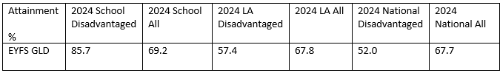
EYFS
18.5% of the year group were identified as disadvantaged with 1 of the disadvantaged group having only joined us in May 2024. There is a significant positive attainment gap between this group and the rest of the cohort. The attainment of the disadvantaged group was above national disadvantaged and national all. The non-disadvantaged group had 5 pupils with an EHCP for significant need.
Year 1 Phonics
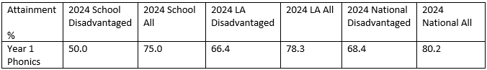
17% of the year group (8 pupils) were identified as disadvantaged with 2 of the disadvantaged group having identified SEND and 2 being PLAC. There is an attainment gap between our disadvantaged and non-disadvantaged group. Only one of our pupils with an additional barrier passed the screen, if we look at the data for our disadvantaged with no other barrier we would have 60% of our disadvantaged pupils achieving the phonics screen.
KS1
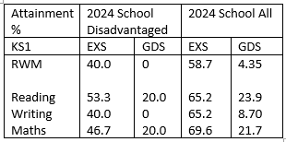

33% of the cohort are identified as disadvantaged, 6 of them with identified SEND needs and 1 with an EHCP. None of our disadvantaged pupils with an additional barrier made EXS, if we look at the data for our disadvantaged with no other barrier we achieve 75% RWM combined, 100% reading 37.5 % GDS reading; 75% writing, no GDS and 87.5 % maths and 37.5% GDS maths. Our disadvantaged were in line with our all for reading and maths GDS.
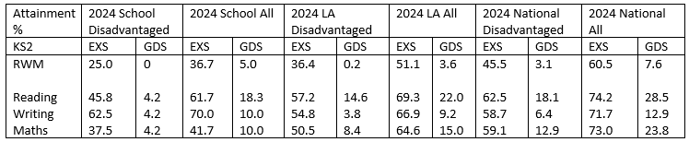
41% of this cohort were identified as disadvantaged, with 38% of the disadvantaged cohort also having an identified SEND need, 3 of whom have an EHCP. If we look at the data for our disadvantaged with no other barrier we achieve 40% RWM combined, 53% reading; 86% writing and 53% maths. This puts us much more in line with national disadvantaged data and local authority disadvantaged data, however still a gap between national all.
Summary
This summary of our data confirms for me that where our disadvantage pupils only have that as their barrier, we are using our pupil premium funding well to close gaps and diminish the disadvantage, this can be seen when you remove the other pupils from the data who have additional barriers. Our KS2 results are weaker across the board as we had a very transient cohort for our current year 6 pupils with 4 pupils joining us in year, 3 of whom moved from Africa, so had not been taught the English KS2 curriculum. We also had 2 pupils on role with us who were not in school and one pupil join us in May 20204 having previously been home schooled. If we re-run the data removing these children so only focussing on the pupils who have been with us for most of their KS2 experience with no additional barriers it looks like this:
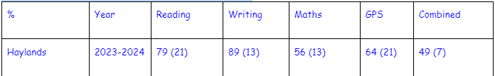
Next Steps:
Our planned outcomes for 2024/2025 as stated in this strategy are still on track for the following year. We need to continue our focus on supporting our disadvantaged ( and non) pupils in maths and writing in particular as these have come through in the data as areas for improvement. Where we get it right for our disadvantage pupils they achieve well. Our in school data for our other year groups is already showing stronger outcomes for all pupils.

Externally provided programmes
Please include the names of any non-DfE programmes that you used your pupil premium (or recovery premium) to fund in the previous academic year.
Programme | Provider

Further information (optional)
Use this space to provide any further information about your pupil premium strategy. For example, about your strategy planning, or other activity that you are implementing to support disadvantaged pupils, that is not dependent on pupil premium or recovery premium funding.

