 | 4-5 (Reception)
Autumn 1 | 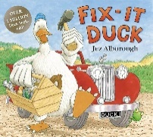  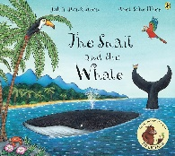  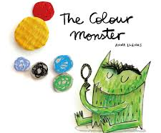  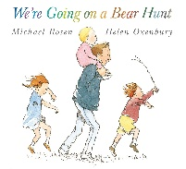  
- Understand how to listen carefully and why listening is important.
-Learn new vocabulary.
-Describe events in some detail.
-Use new vocabulary in different contexts.
-Retell the story, once they have developed a deep familiarity with the text, some as exact repetition and some in their own words.
-Ask questions to find out more and to check they understand what has been said to them.

Write some or all of their name.
Add some marks to their drawings, which they give meaning to. For example: “That says mummy.”

Autumn 2 |   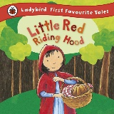    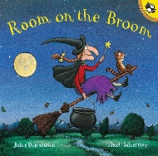  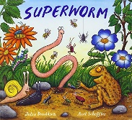  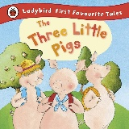  
-Articulate their ideas and thoughts in well-formed sentences.
-Connect one idea or action to another using a range of connectives.
Use some of their print and letter knowledge in their early writing. For example: writing a pretend shopping list that starts at the top of the page; writing ‘m’ for mummy.
Spell words by identifying the sounds (orally)
Spell words by identifying the sounds and then writing the sound with letter/s.
Form lower-case letters

- Understand how to listen carefully and why listening is important.
-Learn new vocabulary.
-Describe events in some detail.
- Write some or all of their name.

Spring 1 |     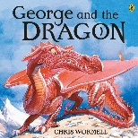  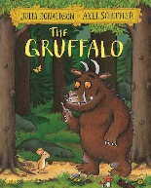  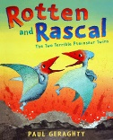  
- Hold conversation when engaged in back-and-forth exchanges with their teacher and peers.
- Participate in small group, class and one-to-one discussions, offering their own ideas, using recently introduced vocabulary
- Write short sentences with words with known letter-sound

- Form lower-case letters correctly.
- Spell words by identifying the sounds and then writing the sound with letter/s.

Spring 2 | 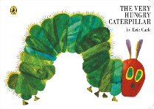  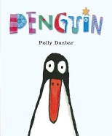      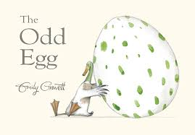
- Express their ideas and feelings about their experiences using full sentences, including use of past, present and future tenses and making use of conjunctions, with modelling and support from their teacher.

- Write recognisable letters, most of which are correctly formed.
- Write short sentences with words with known letter-sound correspondences using a capital letter and full stop.
- Make comments about what they have heard and ask questions to clarify their understanding.
- Begin to Re-read what they have written to check that it makes sense.

Summer 1 | 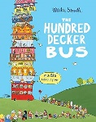    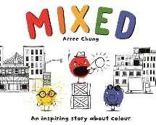    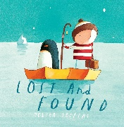  
- Make comments about what they have heard and ask questions to clarify their understanding.
- Hold conversation when engaged in back-and-forth exchanges with their teacher and peers
- Participate in small group, class and one-to-one discussions, offering their own ideas, using recently introduced vocabulary.
- Express their ideas and feelings about their experiences using full sentences, including use of past, present and future tenses and making use of conjunctions, with modelling and support from their teacher.
- Write recognisable letters, most of which are correctly formed.
- Spell words by identifying sounds in them and representing the sounds with a letter or letters.
- Write simple phrases and sentences that can be read by others.
Summer 2 | 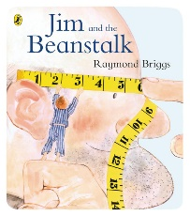  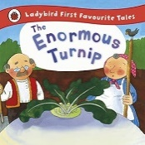  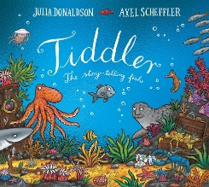  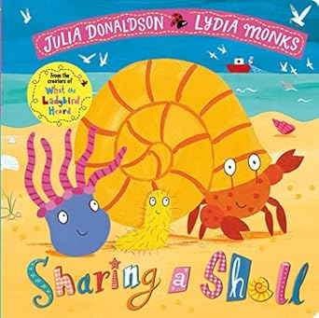  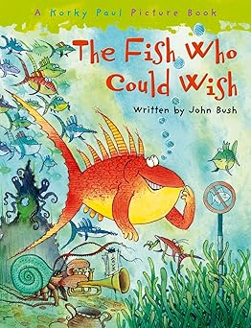  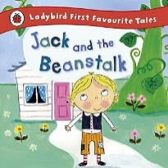  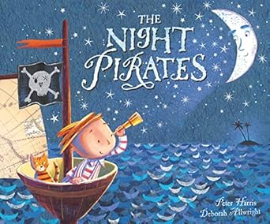
- Make comments about what they have heard and ask questions to clarify their understanding.
- Hold conversation when engaged in back-and-forth exchanges with their teacher and peers
- Participate in small group, class and one-to-one discussions, offering their own ideas, using recently introduced vocabulary.
- Express their ideas and feelings about their experiences using full sentences, including use of past, present and future tenses and making use of conjunctions, with modelling and support from their teacher.
- Write recognisable letters, most of which are correctly formed.
- Spell words by identifying sounds in them and representing the sounds with a letter or letters.
- Write simple phrases and sentences that can be read by others.

