English
- Demonstrate understanding of what has been read to them by retelling stories and narratives using their own words and recently introduced vocabulary.
- Anticipate (where appropriate) key events in stories.
- Use and understand recently introduced vocabulary during discussions about stories, nonfiction, rhymes and poems and during role play.
- Say a sound for each letter in the alphabet and at least 10 digraphs.
- Read words consistent with their phonic knowledge by sound-blending.
-Read aloud simple sentences and books that are consistent with their phonic knowledge, including some common exception words.
- Write recognisable letters, most of which are correctly formed.
-Spell words by identifying sounds in them and representing the sounds with a letter or letters.
- Write simple phrases and sentences that can be read by others.

Maths
Have a deep understanding of number to 10, including the composition of each number.
- Subitise (recognise quantities without counting) up to 5.
- Automatically recall (without reference to rhymes, counting or other aids) number bonds up to 5 (including subtraction facts) and some number bonds to 10, including double facts
- Verbally count beyond 20, recognising the pattern of the counting system
-Compare quantities up to 10 in different contexts, recognising when one quantity is greater than, less than or the same as the other quantity.
- Explore and represent patterns within numbers up to 10, including evens and odds, double facts and how quantities can be distributed equally
Adventures on the High Sea
Communication and Language
- Listen attentively and respond to what they hear with relevant questions, comments and actions when being read to and during whole class discussions and small group interactions.
- Make comments about what they have heard and ask questions to clarify their understanding.
- Hold conversation when engaged in back-and-forth exchanges with their teacher and peers Participate in small group, class and one-to-one discussions, offering their own ideas, using recently introduced vocabulary.
-Participate in small group, class and one-to-one discussions, offering their own ideas, using recently introduced vocabulary;
- Offer explanations for why things might happen, making use of recently introduced vocabulary from stories, non-fiction, rhymes and poems when appropriate;
-Express their ideas and feelings about their experiences using full sentences, including use of past, present and future tenses and making use of conjunctions, with modelling and support from their teacher.
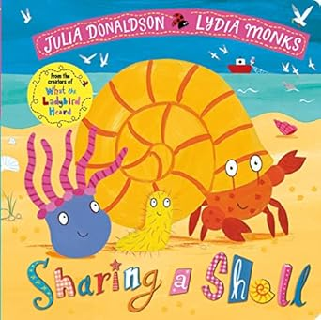
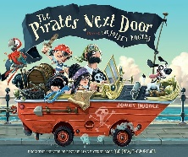
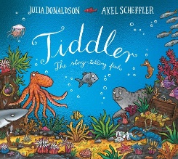
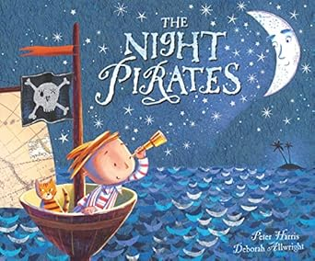
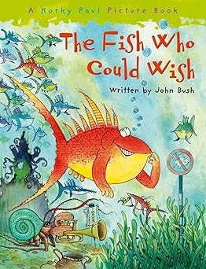
Personal, Social and Emotional Development
We will use 1decision to explore these topics:
-Rainbow Visits the Seaside
Red Goes Swimming
Green Is Moving up a Year
Red Needs The Toilet
Yellow's Bedtime
Physical Development
We will use Get Set for PE to explore this topic:
Games
Move around safely and with control.
Have an awareness of others and items in the teaching space.
Take turns when instructed.
To store equipment safely when not in use
Physical Skills:
run throw change direction catch strike
Expressive Arts and Design
Music: We will use Kapow for:
Big Band:
-Explore, use and refine a variety of artistic effects to express their ideas and feelings.
-Return to and build on their previous learning, refining ideas and developing their ability to represent them.
-Create collaboratively, sharing ideas, resources and skills.
-Listen attentively, move to and talk about music, expressing their feelings and responses.
-Explore and engage in music making and dance, performing solo or in groups.
-Sing in a group or on their own, increasingly matching the pitch and following the melody.
-ELG: Being imaginative and expressive: Perform songs, rhymes, poems and stories with others, and – when appropriate – try to move in time with music.
-ELG: Being imaginative and expressive: Sing a range of well-known nursery rhymes and songs
Art and Design Technology
-Make use of props and materials when role playing characters in narratives and stories.
- Share their creations, explaining the process they have used.

Understanding the World
History
Talk about the lives of the people around them and their roles in society.
- Know some similarities and differences between things in the past and now, drawing on their experiences and what has been read in class.
- Understand the past through settings, characters and events encountered in books read in class and storytelling.
Science and Geography
-understand the effect of changing seasons on the natural world around them.
Describe their immediate environment using knowledge from observation, discussion, stories, non-fiction texts and maps.
- Explain some similarities and differences between life in this country and life in other countries, drawing on knowledge from stories, non-fiction texts and (when appropriate) maps.
- Explore the natural world around them, making observations and drawing pictures of animals and plants.
- Know some similarities and differences between the natural world around them and contrasting environments, drawing on their experiences and what has been read in class.

